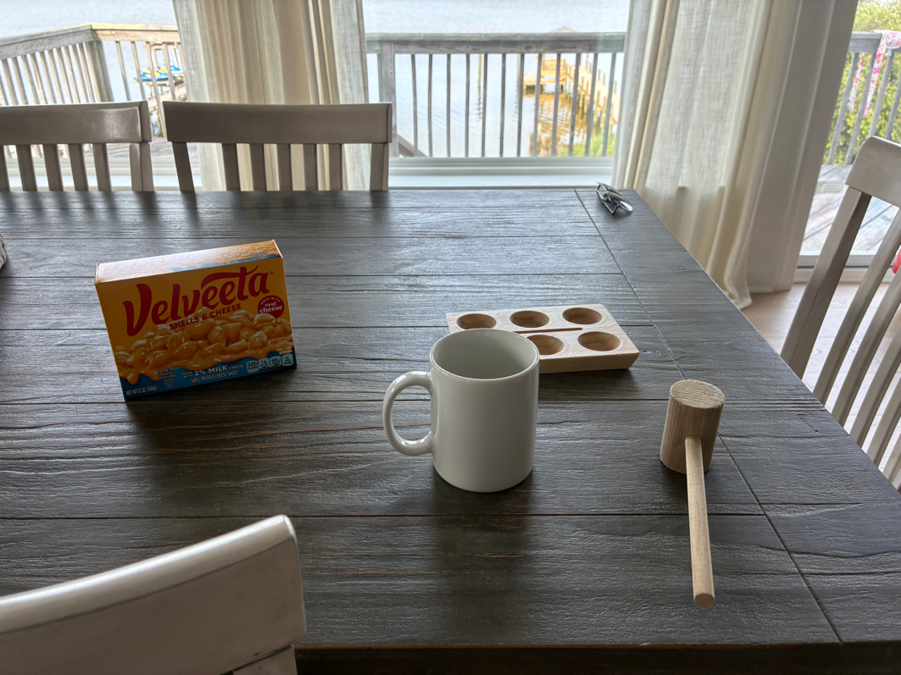
I chose theses real world objects on vacation under pressure since I misread the project guidelines and needed a photo that could be recreated and then found some items around me that were made of simple shapes that I could recreate. I made sure a mug was used since I had already created a decent looking mug. The mug breakdown into a cylinder and a torus the mallet is two cylinders scaled and rotated. The Velveeta box and egg tray are boxes. And the whole in the egg tray are six cylinders grouped together in a two by three grouping to replicate the indentations. To get my final rendering correct I needed three transformations, texturing, and lighting to all work together. The transformation is what created and controlled each objects scale, rotation, and position making sure at the end of each shape I called the correct DrawMesh(). Getting the egg tray cylinders to sit at the correct height and getting the spacing correct was a time-consuming effort that I initially did not consider. For texturing loading the images and having them as the correct file format so they would render properly and have the shape appear. For lighting I had to set the direction and shader material per object to get it to be as close as possible to the picture. I had to add camera controls to move the camera along the forward and right vector with WASD. Then making Q/E control straight up and down along the up vector. Mouse scroll changes the speed of the WASD controls between 1 and 50. Finally the P/O keys switch between a 2D or 3D style camera angle. All those functions run one time inside the PrepareSceneView(), so the camera state is always current to the latest input before each frame is drawn. The custom functions that help with reusability are my set transformations every object in the scene calls the same function before the draw call tee only difference is scale, rotation, and position. Instead of this being rewritten matrix math repeatedly this function builds the model matrix once and uploads it to the shaders. The functions SetShaderTexture(), SetShaderMaterial(), and SetTextureUVScale() help to sperate what an object looks like and what a shape is. We could use this if we owned the Velveeta packaging picture instead of the image, I created all that would need changed is loading the image and update the texture to match the loaded image. CreateProceduralBoxTexture() is the most self-contained example of reusability since it defines its own small set of local helpers that each do one narrow job and the rest of the functions just call the repeatedly with different coordinates to build the whole design. Thank you for being flexible and understanding throughout this semester I greatly appreciate the grace and patience with my work!

